Edgar J. González Serrano

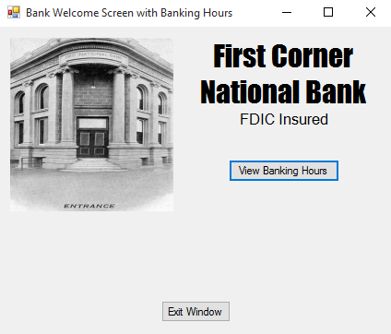 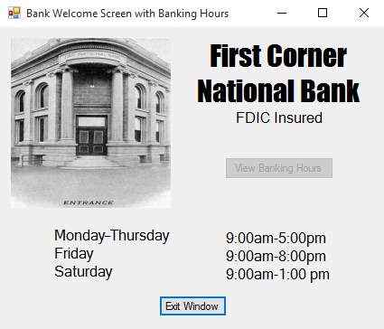

Public Class Form1

Private Sub Button1_Click(sender As Object, e As EventArgs) Handles viewhour.Click

Me.week.Visible = True

Me.hour.Visible = True

Me.viewhour.Enabled = False

End Sub

Private Sub Button2_Click(sender As Object, e As EventArgs) Handles leave.Click

Me.Close()

End Sub

End Class